

**Chi Omega Fraternity**

Gamma Kappa Chapter  
306 Wigwam Hollow Rd  
Macomb, IL 61455

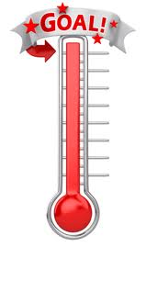April 14, 2014

Dear sponsors and donors:

My name is Allison Hebert and I am a sophomore at Western Illinois University. I am the philanthropy chair for the Chi Omega Fraternity. I would like to personally invite you to our 3rd annual Walk for Wishes on September 27, 2014. This event is a 5k Run/Walk & 10K Run (NEW!) that will take place at Western Illinios University’s Hanson Field and all the proceeds will go to the Make-A-Wish Foundation®. Since 1895, Chi Omega Fraternity has been enriching women’s lives through our unique membership experience. Since Chi Omega's alliance with the Make-A-Wish Foundation® began in 2001, Chi Omega has raised over 9.5 million dollars and has volunteered over half a million hours

**Why Walk?** *It's Supportive & Healthy!*  
You'll be helping hundreds of thousands of children battling life-threatening medical conditions and getting a good workout on top of it!

**Why Donate?** *It's Inspirational!*  
The Make-A-Wish Foundation® relies on the generosity of individuals, corporations and sponsors for wish granting and support programs.  The Make-A-Wish Foundation® is able to share the power of a wish® thanks to the support of generous individual donors.

**Why Sponsor?** *It's Worth it!*  
As a sponsor you are the making events like Walk for Wishes happen all over the nation. Sponsorship brings a spirit of community and volunteerism to your life/business and a commitment to the Make-A-Wish Foundation® which is certainly worth it!  Your sponsorship/donation will help us meet our goal of $5,000 and grant a wish to a child!

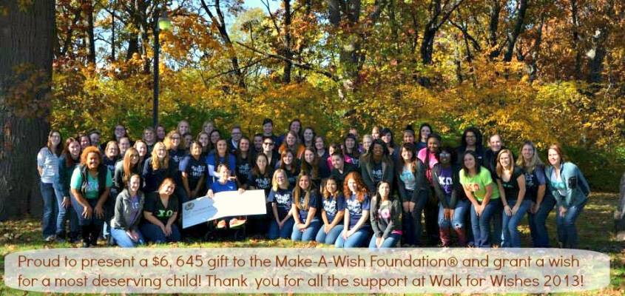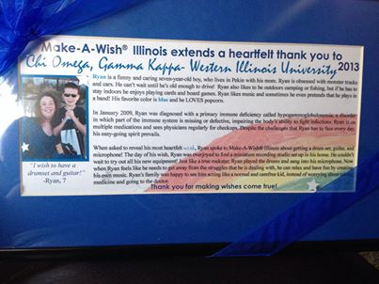

Information about this event can be found at <http://walkforwishes-wiuchiomega.weebly.co>m and you can learn more about the benefits and participation options. Join our ­[FB](https://www.facebook.com/events/553980917976072/) page too! 2014 sites will be live by 5/15/14. We are thankful for your support in making this event possible! Any questions about the upcoming event? Please contact 2014 Walk for Wishes Event Chair, Allison at [AE-Hebert@wiu.edu](mailto:AE-Hebert@wiu.edu).

Allison Hebert

Chi Omega Fraternity- Philanthropy Chair



**All Sponsorship Benefits**

**September 27, 2014 – western Illinois university**

**Due: September 1st 2014**

**Contact Allison: AE-Hebert@wiu.edu**

**Overall Company Benefits**

*With strong brand recognition and grassroots structure, the Make-A-Wish Foundation® can generate significant marketing, media and sales results through our alliances. Corporate Sponsorships have delivered results such as* ***increasing web traffic by more******than 80%*** *and* ***increasing period sales by almost 2%*** *for Make-A-Wish® sponsors.*

* **98% Brand Recognition**

2007 Research via Walt Disney World® Research

* **Ranked in the 60 “strongest and most trusted” brands in the country**

American Brands Council

* **Better Business Bureaus Certification**

Wise Giving Alliance’s Standards for charity Accountability

* **“Best Charities for Kids” 2005**

Good Housekeeping Magazine

* **2008 Gold and Silver Cause Marketing Halo Award**

Best Print Creative and Best Transactional Campaign with Macy’s

**Let The Facts Speak**

*The Illinois Chapter opened in 1985 and proudly grants wishes to children throughout Illinois.*

* Granted over 10,000 wishes since inception
* Granted 766 wishes last year and continue to try to grant more every year.
* Over 1,400 volunteers
* Serves 105 counties, all of the counties in Illinois
* Average value of a wish $8,500

**Employee Involvement Opportunities**

*Become a sponsor and have the opportunity to engage your employees in the community!*

* Create a company Walk team or several teams within the company in order to create friendly competition among co-workers. Invite family and friends to participate as well.
* Participate in workplace fundraisers leading up to event. Fundraisers could include casual Fridays, bake sales, chili-offs, star sales, and other creative events. All fundraising efforts can be tracked online through the *Walk for Wishes* web site.
* Support day-of activities including the three mile walk and post walk celebration.
* Opportunity for employees to volunteer at the event.
* Meet wish children and families at the *Walk for Wishes* event.

**THANK YOU FOR HELPING TO MAKE WISHES COME TRUE!**

***Contributions made to the Make-A-Wish Foundation of Illinois,***

***a non-profit 501(C)(3) charity, are tax deductible as provided by law.***

**Sponsorship Opportunities**

**September 27, 2014 – western Illinois university**

**Due: September 1st 2014**

**Contact Allison:** [**AE-Hebert@wiu.edu**](mailto:AE-Hebert@wiu.edu)

**Signature Sponsor - $1,000**

• Large logo prominently featured on participant t-shirts

• Recognition with linkable logo featured on local Foundation’s web site

• Recognition with linkable logo featured on event fundraising & walk team web site

• Recognition with linkable logo featured on Facebook page and Twitter page

• Company name and logo featured in *Walk for Wishes*® article in newsletter and volunteer e-newsletter

• Company name inclusion on event press releases (time sensitive)

• Corporate banner featured at the staging area

• Free registration of 10 walkers at the Walk for Wishes event

• Verbal recognition at the event as well as opportunity to address participants and volunteers

• Opportunity to provide promotional products to all event participants

• VIP table for employee Walk participants at celebration location after the Walk

# Silver Star - $500

* Medium logo prominently featured on participant t-shirts
* Recognition with linkable logo featured on local Foundation’s Web site
* Recognition with linkable logo featured on event fundraising & walk team Web site
* Recognition with linkable logo featured on Facebook page and Twitter page
* Company name inclusion on event press releases (time sensitive)
* Banner, including corporate logo, featured at post walk wish celebration
* Free registration of 5 walkers at the Walk for Wishes event
* Verbal recognition at the event
* Opportunity to provide promotional products to all event participants

# Wish Star - $250

* Logo featured on participant t-shirts
* Recognition with linkable logo featured on event fundraising & walk team Web site
* Company name inclusion on event press releases (time sensitive)
* Banner, including corporate logo, featured at post walk wish celebration
* Free registration of 2 walkers at the Walk for Wishes event
* Verbal recognition at event
* Opportunity to provide promotional products to all event participants

# Wish Partner - $100

* Recognition with linkable logo featured on event fundraising & walk team Web site (over 1,800 views)
* Free registration of 1 walker at the Walk for Wishes event
* Verbal recognition at event
* Opportunity to provide promotional products to all event participants

**THANK YOU FOR HELPING TO MAKE WISHES COME TRUE!**

***Contributions made to the Make-A-Wish Foundation of Illinois,***

***a non-profit 501(C)(3) charity, are tax deductible as provided by law.***

** 2014 *Walk for Wishes®*   
 Donation/Sponsorship**

Donate by mailing this form and check/cash to:

Chi Omega Gamma Kappa

Memo: Walk for Wishes

306 Wigwam Hollow Rd

Macomb IL, 61455

**Find out more about this event:**

walkforwishes-wiuchiomega.weebly.com/index.html

**Contact Allison:** [**AE-Hebert@wiu.edu**](mailto:AE-Hebert@wiu.edu)

**Business Name ______________________________________________________________**

**First Name________________________ Last Name_________________________________**

**Street Address________________________________________________________________**

**City______________________________________State_________________Zip___________**

**Phone Number_________________________________________**

**Email Address_______________________________________________________**

**TOTAL AMOUNT PAID: $_______________________**

**CASH CHECK #__________________**

**Billing Address_____________________________________________________________**

**City_________________________________________ State_______ Zip ______________  
  
Phone Number ___________________________________________________________**

**THANK YOU FOR HELPING TO MAKE WISHES COME TRUE!**

***Contributions made to the Make-A-Wish Foundation of Illinois,***

***a non-profit 501(C)(3) charity, are tax deductible as provided by law.***

 Chi Omega Fraternity

Gamma Kappa- Western Illinois University

306 Wigwam Hollow Rd, Macomb, IL 61455

January 9, 2014

We just wanted to say THANK YOU!

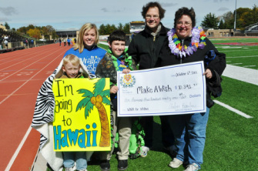Since 1895, Chi Omega Fraternity has been enriching women’s lives through our unique membership experience. Since Chi Omega's alliance with the Make-A-Wish Foundation® began in 2001, Chi Omega has raised over 9.5 million dollars and has volunteered over half a million hours for Make-A-Wish Foundation®. Chi Omega women are truly making a difference in their communities as they help make wishes come true and share the power of a wish®. Our Chi Omega chapter at Western Illinois University, wants to continue making a difference and thanks you on the success of our most recent philanthropic event!

We want to thank everyone who attended, sponsored, and donated to the 2nd annual Walk for Wishes 5K Walk/Run event which helped raise funds and resources for the Make-A-Wish Foundation® on October 5, 2013. We gathered on a rainy Saturday morning to walk, run, raise and celebrate with students, faculty/staff, alumni, community members, and local supporters! Through supporting this event, you are the making events and wishes happen all over the nation. Events like these bring more awareness and support towards helping children with life-threatening medical conditions. This year we raised $7,000 together, of which $6,645 went right to the Make-A-Wish Foundation®! We rose close to $18,000 in the last two years with this event!

This year we granted a wish to Ryan, who wished for a rockstar recording studio with a guitar, drum set and microphone! Ryan is a 7 year old with hypogammoglobulonemia, a primary immune deficiency. It continues to be an amazing experience to give this opportunity and be a small part of his and his family's lives. We were also able to meet this year with two volunteers, a prior wish recipient family, who shared a Sunday afternoon to talk about their experience with the foundation, how we can continue to help this organization, and accepted our check on behalf of Make-A-Wish Foundation®! Our goal this upcoming year is to raise $10,000 in order to grant wishes for two more children! We cannot do this without your support- Walk for Wishes 2014 is set for September 27, 2014!

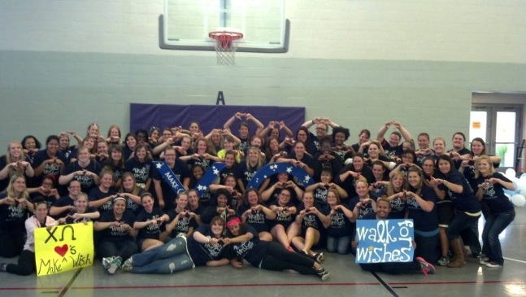

Come out and join us on September 27, 2014 for Walk for Wishes 2014!!! WALK/RUN. DONATE. SPONSOR. $25 per participant.

Early registration will be open May 2014; there is a discount of $5 per registration if submitted by 7/1/14! You can also enter to win a free registration (valued at $25), a $25 gift card, or a football ticket for WIU Homecoming game on 10/4/13 (valued at $20) during this early enrollment.

Register by 8/15/14 for a guaranteed t-shirt. Rain site- Campus Recreation MAC GYM-bring your student ID or State ID. Update on location will be posted on our FB page.

Information about this event can be found at <http://walkforwishes-wiuchiomega.weebly.com/> and you can learn more about the benefits and participation options. Join our FB page too! [www.facebook.com/events/553980917976072/?ref_dashboard_filter=calendar](https://www.facebook.com/events/553980917976072/?ref_dashboard_filter=calendar) We are thankful for your support in making this event possible! Any questions about the upcoming event? Please contact 2014 Walk for Wishes Event Chair, Allison at AE- Hebert@wiu.edu

Gamma Kappa Chapter

309-836-1020

<http://chaptersites.chiomega.com/default.aspx?site=194>